

**Assignment**

**Of**

**ITEC-528 IT Project Management**

**Topic**

**Mobile Banking Application**

**Submitted To:**

**Sir.Sheeraz Laghari**

**Professor Dept:**

**Information Technology**

**Submitted By:**

**Mubashir Ali S/O**

**Mansoor Ali**

**(2k20/ITE/73)Group(A)**

**Make a project plan for a software application that consists of following things:**

**Mobile banking Application**

**1.Introduction**

Is the next big thing. Customers benefit greatly from its cost-effectiveness and ease of Internet, phone, or other electronic delivery-based transactions. One of the most significant technological advancements in the financial sector is electronic finance (also known as E-finance). The provision of financial services and markets through the use of electronic communication and computation is known as e-finance.

**2.Mobile Banking Scope**

Any holding company that serves as the parent company within a banking group will be included in the Framework's application on a fully consolidated basis to ensure that it covers the risk of the banking group as a whole. Groups that primarily engage in banking activities are known as banking groups, and in some nations, a banking group may be registered as a bank.

**3.Major Functions of Mobile Banking**

* Although there are a lot of different kinds of banking software, many of them have the same set of features.
* The problem is that a lot of systems come packaged. They are sold by vendors to numerous market players. Because of this, the functions that are presented have been generalized to satisfy all of the top banking software companies' customers, which range from small fintech startups to multinational corporations.

**Account Management:**

The whole point of using a mobile banking app is to manage information about their bank account right from their phone. Users can check balances, view transaction histories, transfer funds, and monitor their credit cards and bank accounts from any location at any time thanks to features for managing bank accounts.

**Advanced Security & Fraud Alerts:**

Before you can have a successful banking app, make sure it has secure sign-in options. You want to make it so that signing in to a user's online banking account requires specific steps without adding too many that could irritate users. The line between being cautious and paranoid is thin. A successful banking app makes sure that signing in is quick, simple, and secure, giving the user peace of mind. Multi-factor authentication, for instance, is a highly secure technology.

**Banking Features:**

A back-end system known as CORE banking, or centralized online real-time exchange banking, processes transactions and posts updates almost immediately. All kinds of services are available through a variety of digital channels as a result of cutting-edge banking software.

**QR Payments:**

Mobile apps are increasingly using QR codes, which allow customers to quickly and contact-less make purchases by scanning the code with a bar-code reader. Leading banks are now incorporating QR code scanning technology into their applications to join the QR code craze. Merchants and issuers alike can use QR codes to expand the mobile payment options available to their customers.

**Check Deposits:**

For those who still bank in the traditional way, this feature might look like something out of a science fiction novel. However, customers all over the world are becoming increasingly accustomed to using it. One of the most sought-after features of mobile banking is mobile check deposit, also known as remote deposit capture.

**Utility Bills:**

It takes a long time, is inconvenient, expensive, and bad for the environment to pay bills by check. Additionally, it is not exactly the most secure choice. In the mail system, checks are either stolen or lost. They get lost and end up in the recipient's mailbox buried under paperwork. Using a banking app to pay your bills has a lot of great advantages. In addition to the ease of using their smartphone to pay their bills at any time, from any location, users can also set up automatic bill payment options to ensure that they never miss a payment.

**AI Chat-bots:**

A top priority for any service, particularly banking, is always providing excellent customer service and a personalized approach to customers. Intelligent Chat-bots for customer service frequently respond well to straightforward customer inquiries. You will be able to support your customer round-the-clock by incorporating a sophisticated AI chat-bot feature into your banking app, which will increase your chances of success and customer satisfaction.

**4.Performance and Behavior Issues**

Consumer wants their banking app 100% perfect. If there’s any issue with the app it can be very irritating and risky for consumers and also the bank too. We now have the advantage of being able to carry out virtually all of the same actions that we would on a desktop computer while we are on the go thanks to powerful technologies like mobile applications. All financial institutions are moving to mobile banking. Therefore, if you are the owner of a bank and have not yet adopted the mobile app trend, prepare to suffer greatly.

**5.Model For Developing Tools Required**

* The banking software is built using the latest technologies and tools to give seamless banking services and the best customer experience.
* Web applications involve two development processes. Front-end and back-end.
* The front-end developers are responsible for implementing the user interface designed by the UI/UX designers by writing the code. The front-end developers should be skilled in CSS, HTML, and JavaScript.
* The back-end developers deal with tasks such as functionality, performance, data integration, application security, etc. Java and Python are widely used for building financial products.
* The skills you will require in your mobile app developers will depend on the type of mobile banking application you want to launch. Each mobile device operating system calls for a separate skill-set.
* As Banking software deals with users’ private and financial data, security is of primary importance. Your developers should be experts in implementing the latest cybersecurity and application security practices. They should be knowledgeable of the latest security threats like Denial of service, SQL injections, and scripting attacks. They should also know the solutions to prevent them, for instance, data encryption algorithms like DES and RSA.

**6.Total Cost in Development**

The development costs of a banking app are influenced by two main factors: the total amount of time required to develop the software and the developers' hourly wages. The length of time depends on several things, like which platforms were chosen, how complex the features are, what technology stack was used, and so on. The skills, experience, and location of developers typically determine their hourly rates. Using the formula above, you can figure out how much it will cost to build a mobile banking app. However, the table below also shows how much it will cost and how long it will take to build apps of varying levels of complexity.

* The Cost will be depended on the time frame, depends on the overall features with the estimated cost;
* Simple App Cost with basic feature list (60000$) (4-6 Months).
* Medium Complex app with more features list (120000$) (5-8 Months).
* Highly Complex App with advanced features list (200000$) (8 or more months).

**7.Estimation Techniques Applied and Results**

Delphi Technique: A consensus-based approach to estimating effort is known as the Wide-band Delphi technique, after the mythical Oracle of Delphi. The Delphi method, developed in the 1950s and 1960s, is a predecessor to it. The Wide-band Delphi method aims to collect data from expert surveys that are part of the testing process. A moderator and a three- to seven-member estimation team are chosen by the project manager.

UCP = (UUCW + UAW) x TCF x ECF

**8.Project Resources**

Easy Access to DCCU account information while our new mobile apps allows you to stay Connected to your DCCU accounts while on the go.

* Available Balance
* Account transfer
* Biometric Authentication
* Direction to Branches and ATM’s
* Forget Password Code Features.
* Loan Management
* My Spending
* Open an Account Online
* Preview Features

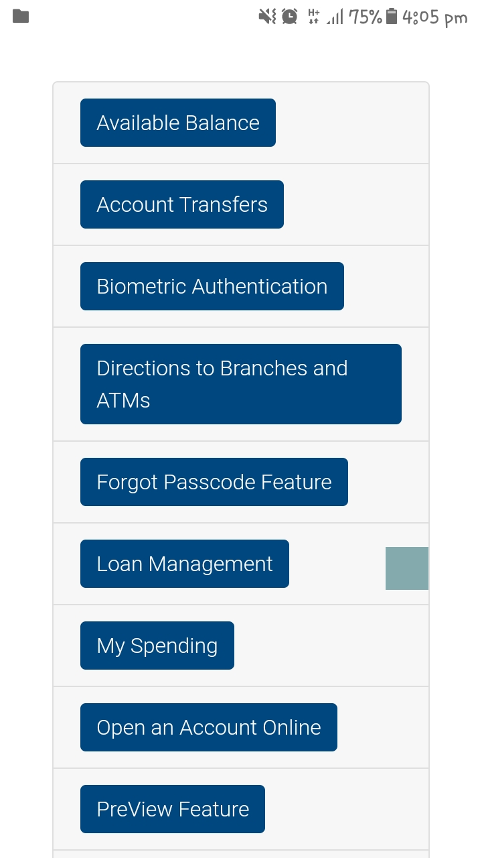

**9.Project Risks**

90% of new companies fail. This sad statistic is an unfortunate reality for many startups in the technology industry, and Fintech is no exception. In this $44 billion fast-paced niche, the stakes are higher, the risks are significantly greater, and the threats are more perilous. Being the target of hacks and cyberattacks is one of the Fintech apps' most common and significant risks. Naturally, this shouldn't be a surprise. Because it deals with people's money and sensitive financial data like bank accounts and social security numbers, fintech is a particularly appealing target for hackers. Indeed, the majority of today's "bank heists" take place online. Cyberattacks on the financial sector increased by 238 percent between February and April 2020, a mere few months, according to a VMWare report.

**12.Function Decomposition**

Although the idea of banks outsourcing particular capabilities across the industry is not new, it has been given new life. With automation, robotics, and cognitive computing today, industry-wide utilities are finally affordable and scalable. The lingering query is: What strategies will regulators, banks, and utility platform providers use to deal with compliance? Who is responsible if a bank transfers a function to a provider that provides a compliant solution in the future? The provider or the bank? Regulators are rushing to keep up with the start-ups as we watch players on both sides of the industry struggle with these gray areas.

**13.Scheduling of tasks using Gantt Chart and Timeline Chart**

**Gantt Chart:**

A horizontal bar chart called a Gantt chart shows the start date and duration of each project task. It is one of the most widely used tools for project management because it lets project managers quickly see how a project is progressing. The American engineer and project management consultant Henry Gantt is credited with inventing the Gantt chart, but he wasn't the first to do so. In the 1890s, a Polish engineer named Karol Adamiecki came up with the idea first. Henry Gantt adapted it for his customers, despite the fact that he made it for his steel-work’s unit. Today, Gantt graphs are utilized most prevalently for project planning and control.

**Timeline Chart:**

Events are arranged in a timeline chart in a logical order. Any unit of time, from minutes to months to years, can be used to measure time. To provide a quick but comprehensive view of the sequence of past or future events, significant dates or milestones are plotted chronologically along a vertical or horizontal time scale. Timeline charts provide stakeholders and project teams with a quick overview of the milestones that have been accomplished or are still to be completed, as well as the due dates for upcoming milestones. The best practice in the industry is to mark deliverable as visible milestones, which emphasizes their urgency. Timeline charts show how long each project task or activity takes, when it starts and ends, how long it takes between tasks, if any tasks overlap, and any dependencies between them. Additionally, it is a useful tool for providing stakeholders with summary reports that detail and highlight your work.

**14.Staff and Team Structure**

Banks and other financial institutions will need to focus more on developing and maintaining their digital services in order to provide customers with a banking experience that is more convenient for them. However, not all businesses have sufficient tech staff, and releasing a top-notch application may necessitate significant resources. Banks can address these technological difficulties while concentrating on their core operations by employing a dedicated digital team from a third-party service provider. The first thing you should do when looking for a digital team to build a mobile banking app is figure out how many specialists are needed and which specialists will handle the project.

**Project Manager:**

A Project Manager (PM) will serve as a liaison between the project sponsor and the entire development team when banks bring their app idea to the software service provider. The PM is in charge of ensuring that a project is delivered according to the agreed-upon budget, time-frame, and quality from the beginning to the end.

**Product Owner:**

In an agile project, a Product Owner (PO) is responsible for putting an app idea into action and making the most of the product's value. To ensure the product's successful launch, this expert will need to learn about the ever-changing requirements of customers, comprehend bank policies, and possess a certain level of technical expertise.

**Business Analyst:**

Business Analysts (BA) have emerged as crucial partners for the scrum team in bringing the product vision to life. They will need to break down high-level product features into user stories with the right amount of detail in order to translate the banks' requirements into detailed documentation.

**Software Architect:**

The app system's planning and organization are the responsibility of a Software Architect. This individual creates high-level architectural diagrams for the online banking system, dictates coding standards, and collects banking requirements.

**UX/UI Designers:**

Nowadays, a lot of digital banking platforms are built with a focus on design and a focus on the customer. To create an appealing app interface, the UX/UI Designer will need to collaborate closely with the product owner and technical engineers.

**Technical Lead:**

To add value to the banking project, Technical Leaders in Agile environments focus on delegating authority and encouraging self-organization among team members. A technical leader in the development of mobile banking apps is essential because they will have the expertise to overcome obstacles when the digital team is unable to.

**Software Engineer:**

Back-end developers and iOS/Android developers are among software engineers' responsibilities:

* Create and maintain high-performance, dependable, and reusable code;
* Guarantee the top notch, execution, and responsiveness of the versatile application;
* Make amends for app flaws and bugs;
* Maintain and update the digital app on a regular basis.

**15.Management Reporting and Communication**

**Management:**

They are used by senior executives and leadership to drive strategic decisions and provide real-time indicators for monitoring business growth. By providing information about your company's finances and operations, they demonstrate the value of your company over a given time period. Management can gain insight into the organization's performance through reporting, enabling them to determine the best course of action for increasing operational efficiency and making pertinent decisions to maintain competitiveness. Professional management reporting software is used by many businesses for this purpose.

**Communication:**

This new phenomenon, which is mostly connected to the internet, is known as an electronic business (e-Business). It has provided businesses with numerous opportunities that can be seen immediately. Managers must devise novel strategies to transform and adapt their organizations to the new changes in this context. Virtually every aspect of business has been profoundly altered by this digital world. However, the banking sector has been most affected by this rapid technological advancement. The banking industry, which serves as the center of the financial sector, provides financial services not only within a country but also globally. Along with virtual banking, PC banking, and online banking, this procedure is also known as electronic banking (e-Banking).

**16.Quality Assurance**

While there is no doubt that the front end is very important to the customer, the users' need for financial and personal information security and quality assurance must now be remembered. So, in banking, what exactly is quality assurance? Well, it covers everything from cloud accessibility and third-party integration to data security, and it is the most important aspect of competing in the new mobile banking world. It is up to quality assurance (QA) to make sure that banking apps can live up to their promises in the face of evolving technologies that can offer users unparalleled experiences in areas such as data security, navigation, and payment gateways.

**Scope and Intent of SQA Activities**

The process of ensuring that all software-related processes adhere to the specified standards is known as software quality assurance (SQA). Analyzing the software requirements for coding is part of it. In addition, it ensures that software development adheres to QA standards and is effective and efficient. In addition, the Software Quality Assurance (SQA) is an ongoing procedure within the Software Development Life Cycle. It checks the developed software on a regular basis to make sure it meets quality standards. From the beginning of development to its completion, SQA analysts evaluate the product's quality. In a similar vein, they guarantee that the software development process will only proceed to the subsequent phase if the standards set for the previous phase have been met. In the industry, there are a number of SQA standards that are well-known.

***The End***